Practice Basic CRUD

1. **Create a database named "Students"**



1. **Create an empty collection named "studentData"**



1. **Insert only one record with appropriate fields.**



1. **Try to insert 5 records together using single query**

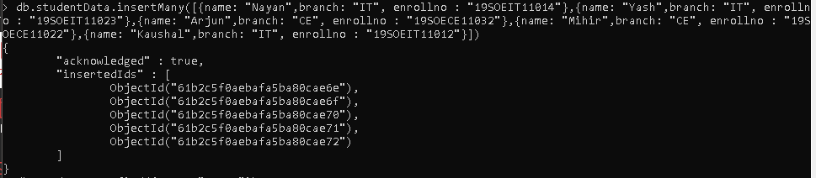

1. **Fetch all the documents in formatted manner.**

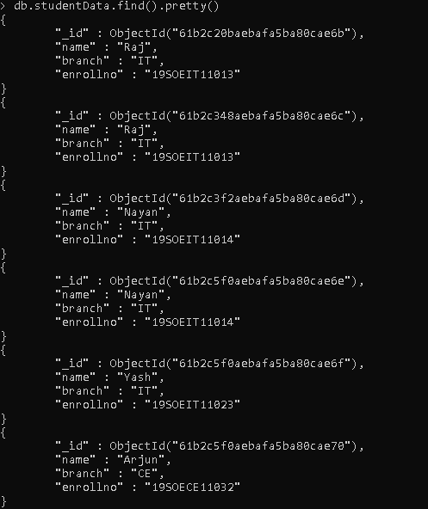

1. 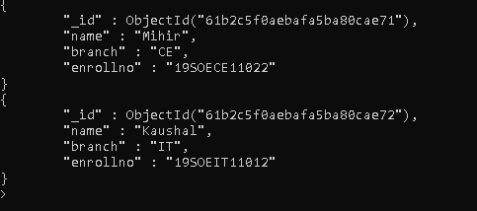**Fetch the document based on the filter criteria.**



1. **Delete one document from the "studentData".**



1. **Delete the documents based on the filter criteria**.



1. **Delete all the documents from the "studentData: collection**



**10.Drop the collection.**

